Scott Tabaka
Instructor: Dr. Mark Hauschild
CmpSci 4732 Summer 2019
Due Date: 7/25/2019

Project #2

Task 1
For this project I have chosen the java 12 environment using the built in crypto libraries.

Task 2
For this task I made a method called "prngBad" and used the LCG equation from the book. When this method ran, it calculates the gcd during each run keeping a running total of each time the gcd =1. After performing 100,000 runs it calculates the number for the random number test to compare to PI. The results below show how the test number was not very equal to PI.

The next method was called "prngGood" and used the built in "SecureRandom" class to generate the random numbers. This method identically performed the same gcd procedure on each run as the bad PRNG method. The test number for this method was very close to PI each time it was run.

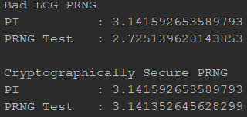

Task 3
First I created 2 text files, one very small 1kb file and one large 1Mb file. Then I created 2 separate .java files, one for AES and one for RSA. The AES program encrypts and decrypts four different setups 1000 times also using 2 different key sizes, 128 bit and 256 bit. The RSA program only encrypts and decrypts each key size 10 times since it was extremely slow. See the results below.

AES
1. small file using a 128 bit key.
2. small file using a 256 bit key.
3. Large file using a 128 bit key.
4. Large file using a 256 bit key.
The program then calculates how many files can be encrypted and decrypted in one second. See results below.

Using these calculations I attempted to calculate what size files could be encrypted and decryption in 1 second.
Using a 128 bit key approximately a 36Mb file.
Using a 256 bit key approximately a 43Mb file.

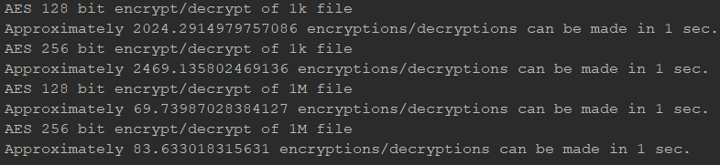

128 bit Calculation:
Total amount of data encrypted and decrypted in 1 sec for 128 bit key divided by 2.
(2000000+69800000)/2=35900000 bytes

256 bit Calculation:
Total amount of data encrypted and decrypted in 1 sec for 256 bit key divided by 2.
(2500000+83600000)/2=43050000 bytes

RSA
Using the RSA algorithm it could theoretically encrypt and decrypt a 32kb file in one second.

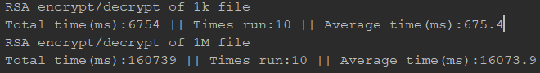
Calculation:
((1000/.675) + (1000000/16))/2=31991 bytes

